**11. ReactJS-HOL**

**Theory**

* React events are similar to HTML events but follow a different syntax and use React’s internal system called Synthetic Events. Events in React are used to handle user interactions like clicks, typing, mouse movements, and form submissions. These events help in making web applications interactive and responsive to user input.
* Event handlers in React are functions that are called when a specific event occurs. For example, if you want to handle a button click, you define a function like handleClick() and pass it to the onClick attribute of the button element, like this: <button onClick={handleClick}>Click Me</button>. These handlers can be either regular functions or arrow functions.
* A Synthetic Event in React is a cross-browser wrapper around the browser’s native event. It is part of React’s event system and is used to normalize events so they behave consistently across all browsers. Synthetic events have the same interface as native events but are optimized by React for better performance and compatibility.
* React follows a camelCase naming convention for events, unlike regular HTML which uses lowercase. For example, in HTML you write onclick, but in React, you write onClick. Similarly, onchange in HTML becomes onChange in React. This consistency in naming helps in maintaining code readability and understanding React’s behavior.

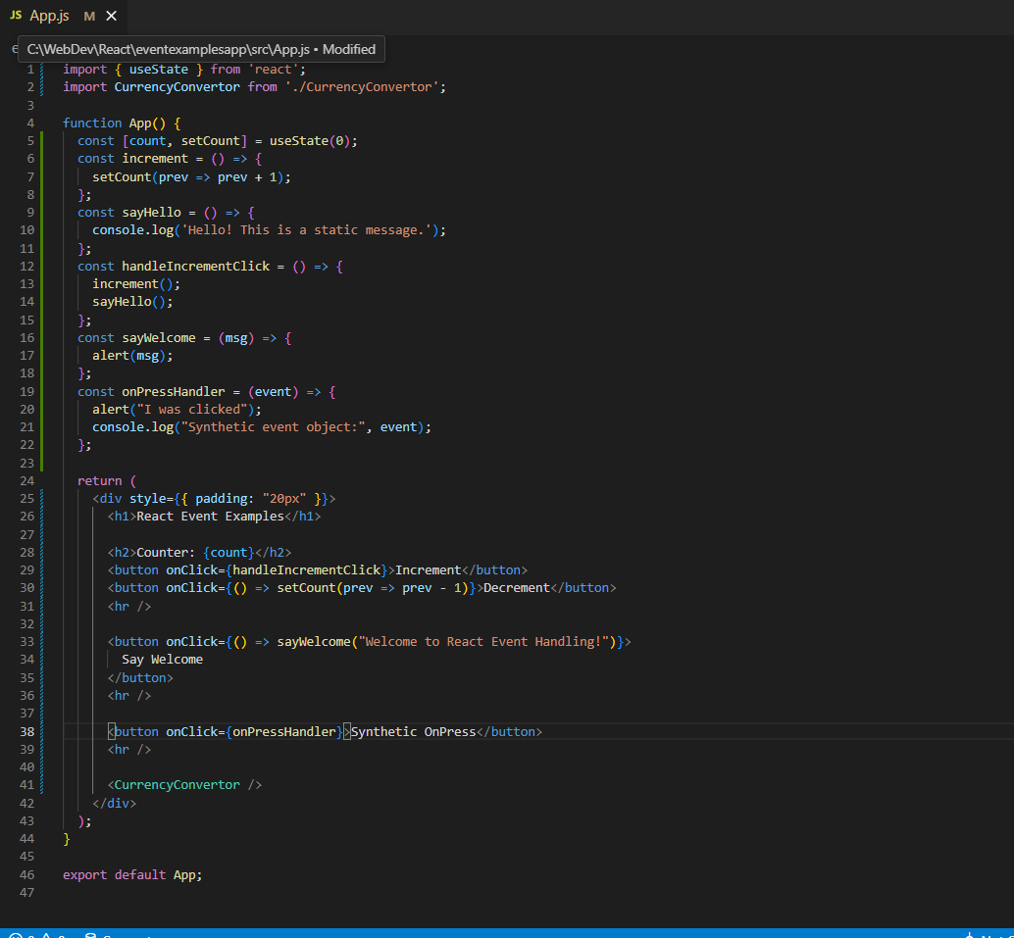

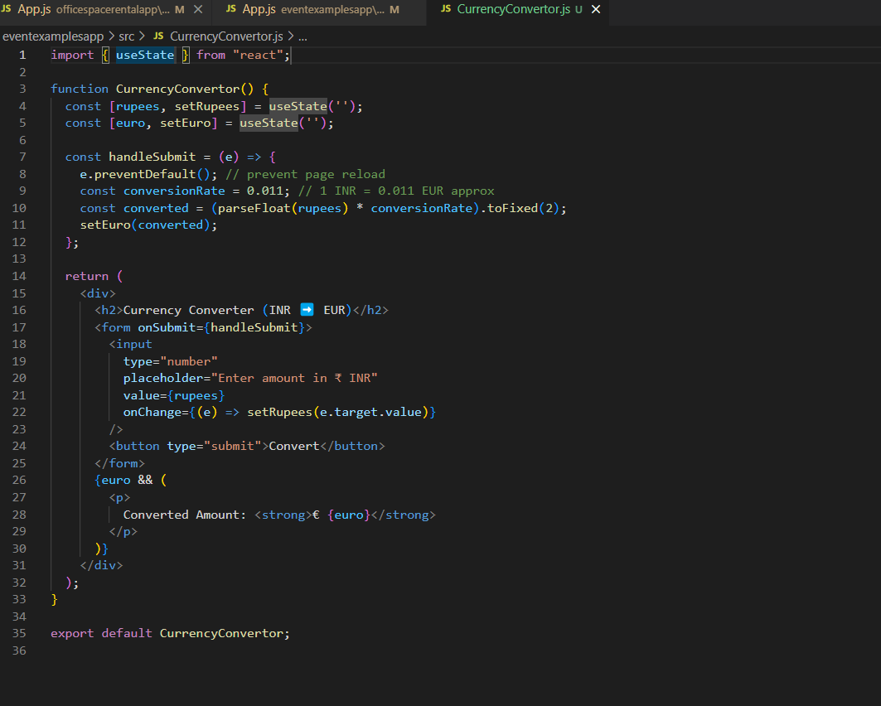

**Output**

